Aerofly Airline Reservation System

Under the supervision of:

**Dr. Ahmed ElNokrashy**

**Eng. Sohaila Mowafy**

|  |  |
| --- | --- |
| **Name** | **ID** |
| Farida Ahmed Ismail | 202000184 |
| Sara Mahmoud Fakhry | 202001825 |
| Habiba Yasser | 202003004 |
| Loujine Waleed | 202000781 |
| Ahmed Moustafa Kamel | 202000896 |

**Table of Contents**

**1.** **Introduction** 3

**1.1 Purpose of the document:** 3

**1.2 Scope:** 3

**1.3 Technologies used:** 3

**1.4 Intended Audience:** 4

**1.5 Overview of the document:** 4

**2.Overall Description** 5

**2.1 Product perspective:** 5

**2.1.1 Product functions:** 5

**2.2 User characteristics:** 6

**2.3 Constraints**: 6

**2.4 Assumptions and Dependencies:** 6

**3.** **Functional Requirements:** 7

**4.** **Nonfunctional requirements:** 9

**5.** **System Interface** 10

# **Introduction**

## **1.1 Purpose of the document:**

The airline reservation system project serves a variety of functions, including flight booking, where passengers can search for a flight and reserve a seat on both domestic and international flights. The system also provides information about flight departures at particular times. The project can be accessed by both users and administrators.

## **1.2 Scope:**

Our airline reservation project's main objective is to completely transform the booking experience by streamlining and automating the reservation procedure. Our goal is to greatly shorten reservation times while improving passenger involvement and interaction. Our project is unique in that it makes creative use of database system that was created to maximize user experience (UX) and expedite processes. Furthermore, we are dedicated to creating a user-friendly and intuitive user interface (UI) so that travelers may easily manage the reservation system. Our schedule attempts to complete the project by the end of this course, December 2023.

## **1.3 Technologies used:**

1. Front-End Technologies:

HTML/CSS/JavaScript: for developing the reservation system's user interface and experience inside web browsers.

1. Back-End Technologies:

Databases: Database management system like MySQL is utilized to keep track of reservations, flight information, user data, and other pertinent data.

1. Coding Language: Java

## **1.4 Intended Audience:**

1. Developers: Are responsible for writing, testing, and maintaining the code for the software. They need detailed technical documentation, coding standards, and access to project requirements.
2. Software Testers: Testers are responsible for identifying and reporting defects and issues in the software.
3. Project Managers: Are responsible for planning, organizing, and overseeing the project. They need project plans, timelines, progress reports, and resource allocation information.
4. SCRUM Masters (in Agile projects): In Agile methodologies like Scrum, the Scrum Master facilitates the Agile process and ensures that the team adheres to the methodology.
5. Project Supervisor: These individuals provide leadership and guidance to development teams. They need detailed insights into team progress, blockers, and resource needs.
6. Customer

## **1.5 Overview of the document:**

The document is going to provide a lot of information about an airline reservation system.It will also explain in detail what this system should do and what users want from it. In the following chapters, the document will focus on how they plan to create the implementation of the interface “the part of the system that users see and use”. They will describe all the rules, diagrams, and other important details and requirements that the 'Airline System' must follow and use.

# **2.Overall Description**

## **2.1 Product perspective:**

• The airline reservation system is an autonomous and self-contained system with an intuitive user interface.

• It is designed to meet the needs of two distinct user types: passengers and administrators, each having unique sets of activities and privileges within the system.

• The system is built around a centralized database that stores all relevant information, ensuring data integrity and consistency.

• This application is compatible with Android smartphones running version 4.2 or higher, ensuring accessibility and usability for a broad range of users.

• It functions as a mission-critical tool within the aviation industry and interfaces with various stakeholders, providing a reliable and secure platform for airline reservation and management.

### **2.1.1 Product functions:**

1. User Registration and Authentication.

2. Flight Search and Availability.

3. Booking and Reservation.

4. Payment Processing.

5. Booking Modifications and Cancellations.

6. Flight Scheduling and Management.

7. Security and Compliance.

8. Customer Support and Notifications.

9. Admin Control Panel.

## **2.2 User characteristics:**

In the context of the airline reservation system, there are two distinct user roles: customers and administrators.

1. **Customers:**

* Proficiency in the English language is essential for customers as the system primarily operates in English.
* Customers are expected to have some prior experience using general Android applications or computer software, ensuring a basic level of tech-savviness.

1. **Administrators:**

* Administrators are required to undergo training to effectively use the application. This training is necessary to ensure they can efficiently manage the system and perform their administrative tasks.

## **2.3 Constraints**:

The system is constrained by its need for a functioning internet connection since all the passenger and flight data required for the application to run is kept in a database which the system must constantly be ready to access. For the application to function, a reliable internet connection is therefore necessary.

## **2.4 Assumptions and Dependencies:**

Users will use their respective mobile app stores to download the application.

• It is considered that every user of the system has internet access.

• It is presumed that all users are familiar with English and have used online booking tools before.

The system relies on a current database to hold all updated user, booking, and flight data.

# **Functional Requirements:**

* 1. **The User**
     1. **Account registration**
* **Sign in**

Users can log in to their accounts using their username and password.

* **Sign up**

Users can create a new account within the application.

* + 1. **Flight selection**
* **Search for flights.**

Users can search for flights by specifying the destination, flight origin, departure date, and return date.

* **Flight type and details.**

Users can choose flight preferences, such as one-way or round trip, specify the number and type of passengers (adults or children), and select their preferred type.

* **Matching flights**

After entering flight details and preferences, the system displays flights that match the user's criteria. If no exact matches are found, the system shows the closest options. If no flights are available, a notification is shown.

* + 1. **Help center**

Users can send messages to the help center if they encounter any issues while using the app. The help centers respond to their requests within 24 hours.

* + 1. **Booking**
* **Conformation messages**

Upon booking a flight, the system sends visual confirmation on the app and a booking confirmation email to the user's provided contact.

* **Cancellation**

Users have the option to cancel a reservation and record ticket information, including confirmation number, name, date of journey, and the fare deducted.

* **Cancellation response**

Users can view the response received from the system after requesting a reservation cancellation.

* + 1. **Currency selection**

Users can choose their preferred currency while searching for flights.

* 1. **The Admin**
     1. **Access Details of Existing Booking**

The admin user can retrieve and review the details of existing bookings.

* + 1. **Modify Existing Flights**

The admin user is empowered to make changes to the details of existing flights.

* + 1. **View Reservation Cancellation Requests**

The admin user has access to view requests for reservation cancellations.

* + 1. **Accept Reservation Cancellation Requests**

The admin user has the authority to accept reservation cancellation requests.

* + 1. **Delete User**

The admin user is equipped to delete user accounts as needed.

* + 1. **Delete Flights**

The admin user possesses the capability to remove flights from the system when required.

* + 1. **Add New Flight**

The admin user has the ability to add new flights to the system.

# **Nonfunctional requirements:**

• Performance: Specifies response times, scalability, throughput, and resource utilization.

• Reliability: Involves availability, fault tolerance, and data integrity to ensure continuous and secure operation.

• Availability: The system must be capable of continuous operation, functioning 24 hours a day, seven days a week without interruption.

• Reliability and Maintainability: Specifies error handling and backup/recovery procedures to minimize disruptions.

Repo Link (Github): gh repo clone faridaahmed36/SoftwareProj_AirlineSystem

<https://github.com/faridaahmed36/SoftwareProj_AirlineSystem.git>

# **System Interface**

**Home Page:**

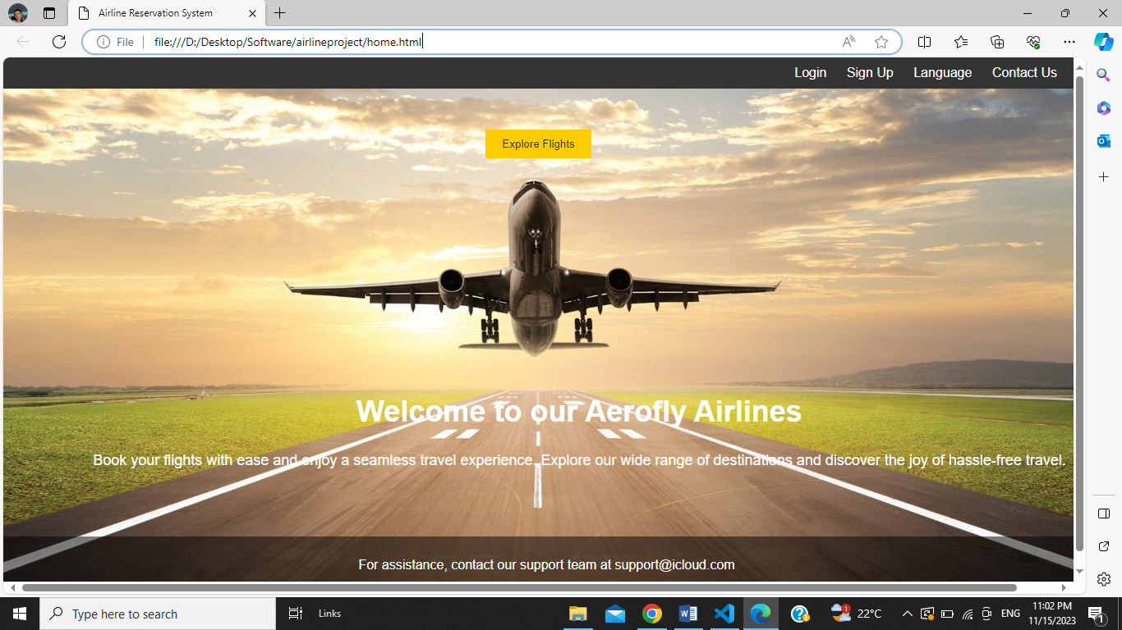

**Sign Up:**

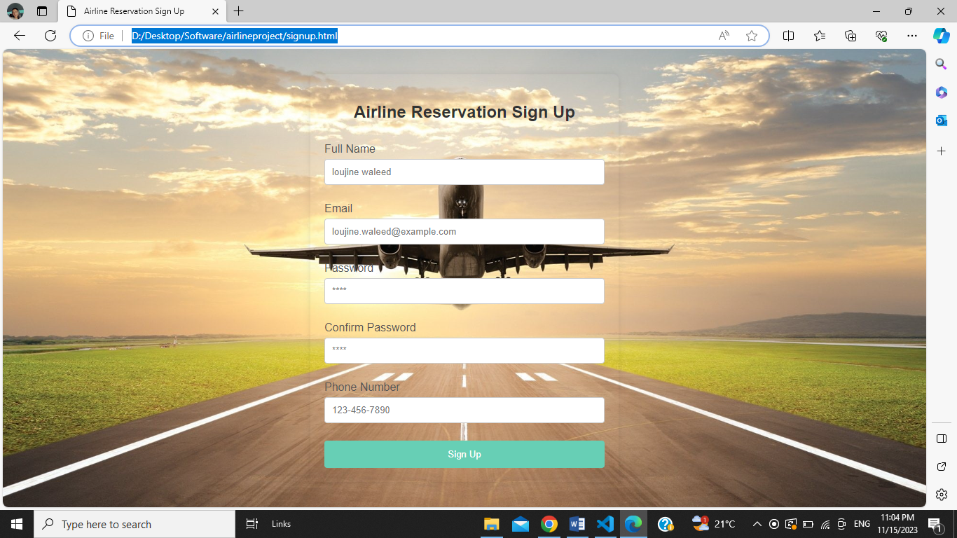

**Searching for flights:**

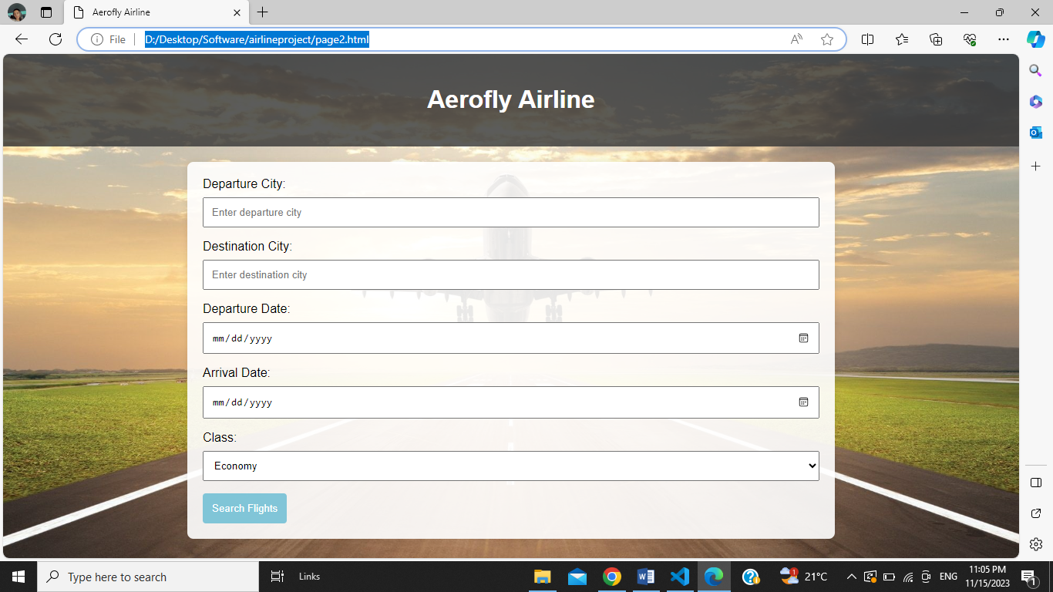

**Flight Results:**

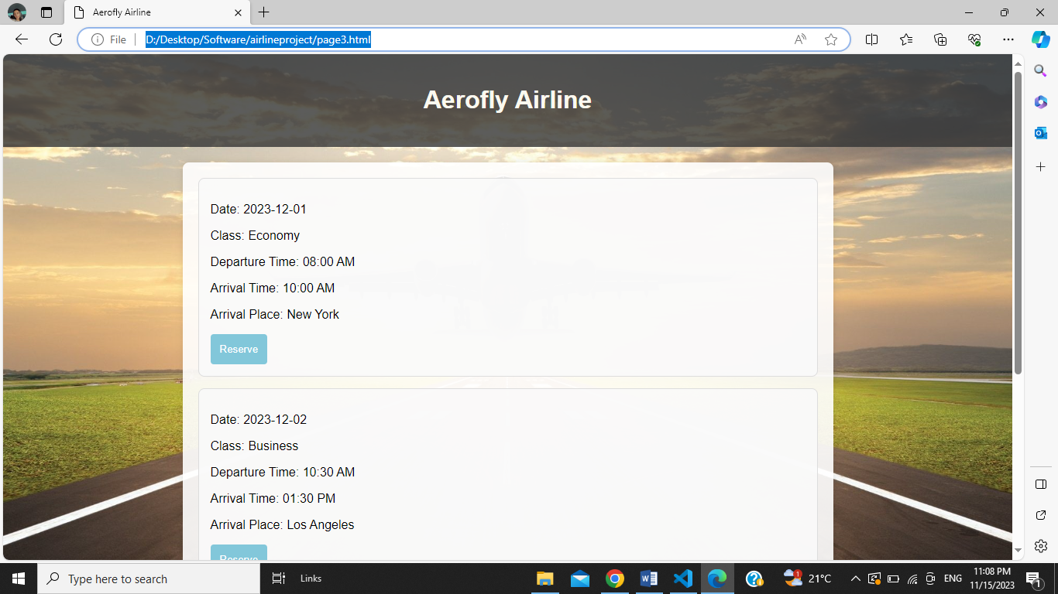

**Flight payment:**

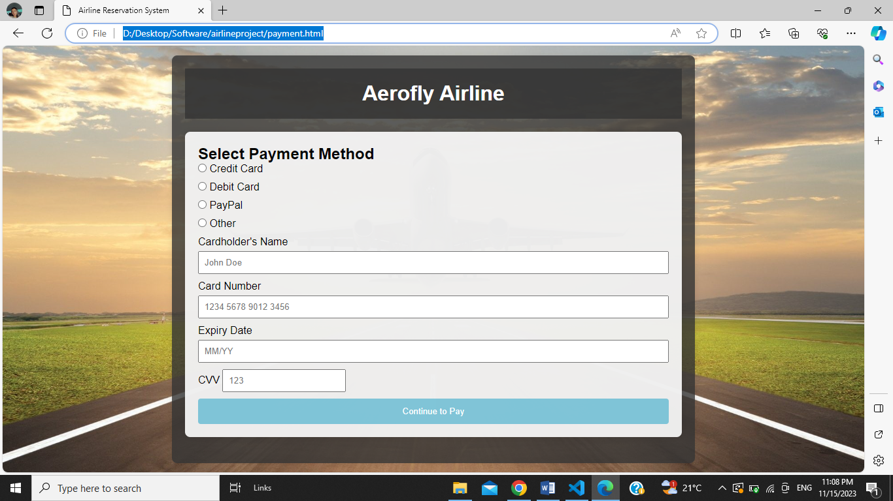

**Support Center:**

